# **GENERAL INFO**

* *Course: 313CCS-5*
* *Assignment no: 2*
* *Marks: 4 marks*
* *Due Date on 21-May-2023*
* *Submit on Blackboard 1 pdf file.*
* *For extra credit, the game should be uncommon, and algorithms should be well written*
* *For issues, email me immediately.*
* ***Important Note!*** 
  + *You are not allowed to use any external sources without citation, including any AI-assisted tools.*
  + *Your answer must show and reflect your effort and views.*

Find or **invent a board game notion that involves challenges and more than one player.** Then, answer the following questions.

1. **What is the name of your game (if it does not, make one)?**

**Call of Duty run on ios/android/sony/pc/xbox**

1. **Sketch or draw the game idea and the board if available.**

The game is a war games require the players to be in a group helping each other.

In the game the player can choose to play with first person or third person.

You can select the type of your plays the clothes hair also the car and the guns.

There are multiple maps to switch between them so you will not get bored.

The game offers mic and also chat as npcs so the player can communicate with each other.

In every map there are buildings, houses, schools, airports, mountains and a lot of objects you can hide in them or find a lot of resources you will need it in the game.

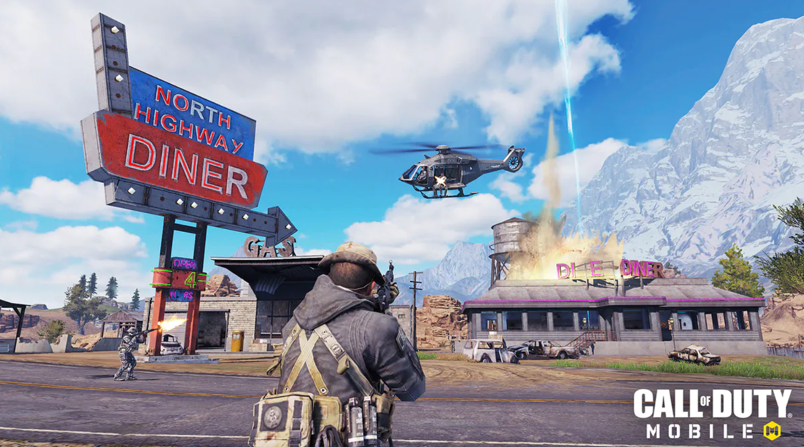Here screenshot of the game:

1. **Write about how to play the game?**

Create a team with your friends out of 4 players.

Start to choose the clothes style the guns also the map you want to play in

After the start of the game go to collect the resources you need

Help your friends if they were shoot by enemies

Try to kill the other teams

1. **What are the Game Rules, including winning and losing events?**

• you can’t kill your team or throw a ned on them or you will take a band

• You must first eliminate the opposing teams.

• Help your teammates heal and guard their backs.

• To win, you must kill all of the other players.

• To lose: your blood counter will be zero.

1. **Write an algorithm for loading and saving the player’s data. Start, for example, start from “when the user clicks ctrl+s ”. (Note! The data and their types must be clearly specified)**

Ctrl+s:

1. player create file and give it a name.

2.the file should be open in write mode

3.player name(string)

4.level passed(int)

5.close,saved

To load the game:  
1. player write the name of file

2. open file in read mode

3. put the information you put it when you saved the file

4. close the file, loaded

1. **Explain if there is an economic system, spawning process, or use of Randomness in the game?**

The economic system in the game is very clear and easy also is make the game in equal state

The system depends on the texture and skins of the players there style bags looks cars and like these things if the player want to buy dress foe example he should pay with real money then the game convert them into coins in the game now he can buy that dress.

But for the other resources it can be found randomly inside the game mode for all players at the same level.